**TED Talk. The History of the World in 18 Minutes[1]**

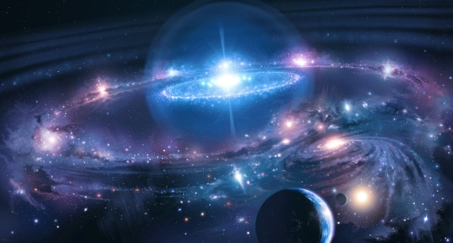

**SPEAKING**

1. **Discuss with your partner:**
2. How old is the universe? How did it appear?
3. What is the title of our galaxy?
4. How many planets are there in our Solar System?
5. What’s the difference between a star and a planet?
6. When did human beings appear?

**VOCABULARY**

1. **Look at the words below. Discuss their meanings with your partner. In which context might they be used the video? Complete the sentences with them.**

***mammal******template threshold******a scrambled egg******DNA******complexity hydrogen Goldilocks******fragile******fossil fuel*** ***_______________flourish******error***

1) To cook ______________ you should break it, mix and then heat and stir it in a pan.

2) Our world is a global system of stupendous______________ .

3) The universe creates complexity under ___________ condition – not too hot, not too cold, but just right.

4) At each stage of the world’s development something new appears out of nowhere. We refer to these stages as _______________ moments in the history of the universe.

5) Initially, the universe consisted of huge clouds of _________________ and helium.

6) The stage introduces organisms that are more _____________ and vulnerable, but they're also much more creative. I'm talking, of course, about living organisms.

7) How do you stabilize those huge molecules that seem to be viable? Well, you don't stabilize the individual; you stabilize the______________ , the thing that carries information.

8) ____________ determines the particular structure and functions of every cell

9) As DNA copies itself, once in every billion cases, there is an ____________. Something goes wrong.

10) Landing of the asteroid was terrible news for the dinosaurs, but great news for our ______________ ancestors, who flourished in the niches left empty by the dinosaurs.

11) ______________ is fuel such as coal or oil that is formed from the decayed remains of plants or animals.

12) We're burning fossil fuels at such a rate that we seem to undermine the Goldilocks conditions that made it possible for human civilizations to _____________ over the last 10,000 years.

**VIEW**

1. **Watch the video. Complete the table with the missing information.**

|  |  |  |
| --- | --- | --- |
|  | **What happened?** | **When did it happen?** |
| 1 | The universe appeared | ____________________ |
| 2 | The universe consisted of huge clouds of hydrogen and helium atoms, and they had no structure | ____________________  ____________________ |
| 3 | _______ began to appear all through the universe, billions of them. And the universe was now significantly more interesting and more ______________ | about 200 million years after the Big Bang |
| 4 | Our solar system was formed | ____________________  ____________________ |
| 5 | ____________________ were created | at the next stage |
| 6 | ____________ organisms appeared. These included fungi, fish,  plants, amphibia, reptiles, and then, of course, the __________. | about 600 to 800 million years ago |
| 7 | Humans appeared | ____________________ |
| 8 | Humans ____________________ | 10,000 years ago |
| 9 | Humans started using fossil fuels | ____________________ |

1. **Answer the questions**

1) Which law of thermodynamics is mentioned in the video? In which context?

2) What was the universe like when it appeared?

3) What was happening with the clouds of helium and hydrogen, which finally led to the creation of stars?

4) What was required for the living organisms to appear?

- ________, but not too much;

- a great diversity of ___________ ___________;

- liquids, such as __________.

5) How is DNA learning?

6) What enables people to accumulate what they’ve learnt?

7) Which part of the world did the humans come from?

8) What dangers does the humanity face nowadays?

**READING**

1. **Read the text ‘The Little Ice Age’ and do the tasks to it.[2]**

1. <https://www.ted.com/talks/david_christian_big_history>
2. Cambridge IELTS 8. Student's Book with Answers: Official Examination Papers from University of Cambridge ESOL Examinations, Volume 8. – Cambridge University Press,  2011. – 176 p.